**Title of Report**

**Times New Roman (16 points, Bold)**

**No More Than Three Lines**

[Photo Optional]

**Your Name**  
 **Name(s) of Your Group Members**

**Name of Course**

**Submission Date**

**Abstract**

One short summary paragraph that describes what the paper will cover. **R**ecap- What did you do, and how? Explain in a sentence or two, no more. **R**eason-Why is this experiment important to the study of science? **R**esults- State the important qualitative (major relationships discovered) and quantitative (numerical) result(s) with percent error when appropriate. This summary should stand alone (no reference to figures or tables in the text) and present the most important results of the work.

XXXXX XXXXXXXXXXXXXXXXXXXXXXXXXXXXXXXXXXXXXXXXXXXXXXXXXXXX XXXXXXXXXXXXXXXXXXXXXXXXXXXXXXXXXXXXXXXXXXXXXXXXXXXXXX XXXXXXXXXXXXXXXXXXXXXXXXXXXXXXXXXXXXXXXXXXXXXXXXXXXXX XXXXXXXXXXXXXXXXXXXXXXXXXXXXXXXXXXXXXXXXXXXXXXXXXXXXXXX XXXXXXXXXXXXXXXX.

**Introduction**

The introduction is typically 1-3 paragraphs long, and includes the following: a detailed description the objectives of the lab and why you are performing this experiment. Students must also provide background information to the reader. Students may also have to insert or explain the following:

Models or particle representations / **Free Body Diagrams**

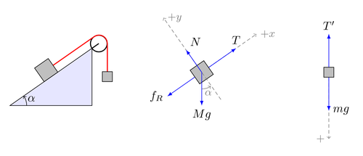

Figure 1: name and description of figure

or **balanced** chemical reactions:

2 H2 (g) + O2 (g) → 2 H2O (l)

H+ (aq) + HSO4- (aq) ↔ H2SO4 (aq)

Figures demonstrating lab equipment/ set-up (no need to draw beakers, rulers, balances, etc.) *[Your device is great for documenting lab set ups!]:*

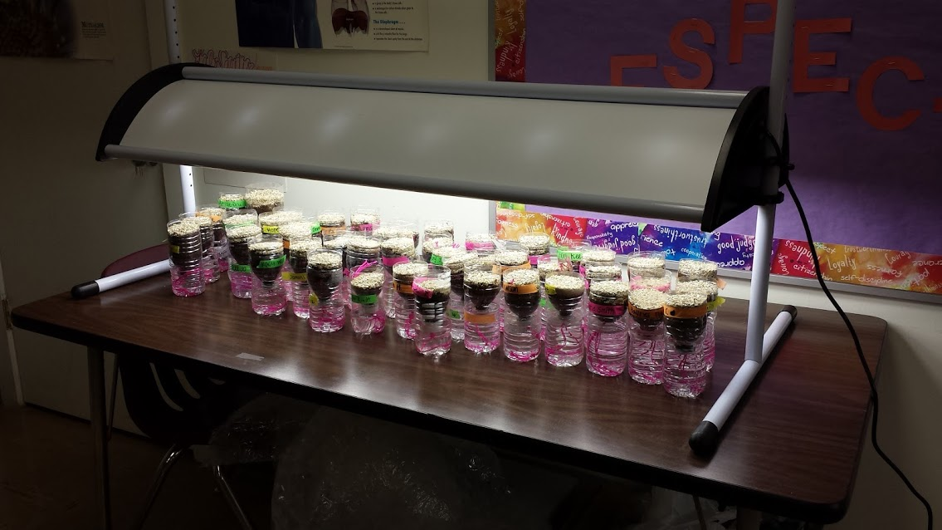

Figure 2: "Wisconsin fast plant" bottle planters under 24 hour grow lights.

Additional inclusions should be: theories/ laws/knowledge used, special equipment with descriptions and purpose, and appropriate SI units.

**Procedures and Methodology**

Write about the general strategy used to obtain the data. Identify the equipment you have used and the data collection techniques. Describe your procedures in such detail that a knowledgeable reader could reproduce your experiment or analyze potential flaws. This section should be no longer than two pages. Anything past two pages will not be graded. The intent of this section is to: (1) summarize the experimental strategy, (2) identify what aspects of the equipment and procedure are significant to the outcome of the experiment, (3) not copy the lab handout, unless you use an in text citation of the handout as a reference, and (4) include a bulleted Materials List (dependent on the specific lab instructions)

**Results**

This section is the repository of collected information. Include tables, graphs, and calculations as exemplified below with a description of each. Full paragraphs are not necessary - analysis of results will be written about in the discussion section of report.

Tables - Include data and organize it into tables. Only include raw data in a formal lab report if noted. TABLES HAVE TITLES, FIGURES (GRAPHS) GET CAPTIONS.

Table 1: Experimental Measurement of the Spring Constant

|  |  |  |  |
| --- | --- | --- | --- |
| Mass (kg) | Displacement (m) | Acceleration due to Gravity (m/s2) | Spring Constant (N/m) |
| 0.200 | 0.175 | 9.8 | 11.2 |
| 0.100 | 0.090 | 9.8 | 10.9 |
| 0.050 | 0.044 | 9.8 | 11.1 |
|  |  | **Average Spring Constant**  **(N/m)** | **11.1** |

Graphs - Whether made on graph paper or on the computer, always:

-Give the graph a title.

-Label the axes with a scale and units.

-TABLES HAVE TITLES, FIGURES (GRAPHS) GET CAPTIONS.

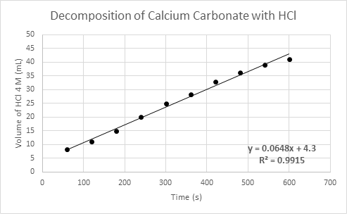

Figure 3: The rate of decomposition of calcium carbonate over time with the addition of 4 M hydrochloric acid via buret

Calculations**:** Show all calculations, including formulas and units. For repeated calculations, include 1 sample. *To insert equations, it may be necessary to edit this document in the desktop version of Word.*

**Discussion**

THIS IS THE MOST IMPORTANT PART OF THE LAB REPORT. YOU ARE SHOWING YOUR READER THAT YOU UNDERSTAND THE MEANING OF YOUR EXPERIMENT!! Paragraph form should be used, and this should be the longest section of the report.

State your claim and support it with multiple forms of evidence, referencing your tables, graphs, and calculations from the results section. Evaluate your initial claim, if there was one. If your initial claim was not supported by your data, and outside the limits of your % error, suggest reasons for this. Were your assumptions wrong? Estimations wrong?

Examine **multiple** sources of error, explaining specifically how they would have affected your results. Never say “human error” or blame your lab partner (if you did the lab wrong, then you do it again!) Usually you will be looking for problems with the equipment or procedure. List the errors and explanations in order of importance. See "Common Sources of Error" document provided in appendix.

Suggest realistic ways to improve or enhance the experiment, in terms of equipment and/or procedure.

Suggest real-life applications for your results, and ***thoroughly*** explain why it is relevant.

Finally, restate important findings and use them to draw conclusions.

**Raw Data and Post Lab Questions**

See your instructor for more details

Students will use APA format to include any texts, journals, or ACADEMIC websites they used as reference materials. This will always include your textbook.

References

Allain, Rhett. *Common Sources of Error in Science Lab Experiments.* Southeastern Louisiana University. Retrieved from https://www2.southeastern.edu/Academics/Faculty/rallain/plab193/labinfo/Error_Analysis/06_Sources_of_Error.html.

[Fauske](http://www.texample.net/tikz/examples/author/kjell-magne-fauske/), Kjell M. (2008, Oct. 15). *Example: Free Body Diagrams*. Retrieved from http://www.texample.net/tikz/examples/free-body-diagrams/.

**Common Sources of Error in Science Lab Experiments**

**There is no such thing as "human error"!** This vague phrase does not describe the source of error clearly. Careful description of sources of error allows future experimenters to improve on your techniques. This ***long list*** of common sources of error is meant to help you identify some of the common sources of error you might encounter while doing experiments. If you find yourself stuck for words when describing sources of error, this list may help. The list goes from the common to the obscure.

**Incomplete definition** (may be systematic or random) - One reason that it is impossible to make exact measurements is that the measurement is not always clearly defined. For example, if two different people measure the length of the same rope, they would probably get different results because each person may stretch the rope with a different tension. The best way to minimize definition errors is to carefully consider and specify the conditions that could affect the measurement.

**Failure to account for a factor** (usually systematic) - The most challenging part of designing an experiment is trying to control or account for all possible factors except the one independent variable that is being analyzed. For instance, you may inadvertently ignore air resistance when measuring free-fall acceleration, or you may fail to account for the effect of the Earth's magnetic field when measuring the field of a small magnet. The best way to account for these sources of error is to brainstorm with your peers about all the factors that could possibly affect your result. This brainstorm should be done before beginning the experiment so that arrangements can be made to account for the confounding factors before taking data. Sometimes a correction can be applied to a result after taking data, but this is inefficient and not always possible.

**Environmental factors** (systematic or random) - Be aware of errors introduced by your immediate working environment. You may need to take account for or protect your experiment from vibrations, drafts, changes in temperature, electronic noise or other effects from nearby apparatus.

**Parallax** (systematic or random) - This error can occur whenever there is some distance between the measuring scale and the indicator used to obtain a measurement. If the observer's eye is not squarely aligned with the pointer and scale, the reading may be too high or low (some analog meters have mirrors to help with this alignment).

**Instrument resolution** (random) - All instruments have finite precision that limits the ability to resolve small measurement differences. For instance, a meter stick cannot distinguish distances to a precision much better than about half of its smallest scale division (0.5 mm in this case). One of the best ways to obtain more precise measurements is to use a null difference method instead of measuring a quantity directly. Null or balance methods involve using instrumentation to measure the difference between two similar quantities, one of which is known very accurately and is adjustable. The adjustable reference quantity is varied until the difference is reduced to zero. The two quantities are then balanced and the magnitude of the unknown quantity can be found by comparison with the reference sample. With this method, problems of source instability are eliminated, and the measuring instrument can be very sensitive and does not even need a scale.

**Failure to calibrate or check zero of instrument** (systematic) - Whenever possible, the calibration of an instrument should be checked before taking data. If a calibration standard is not available, the accuracy of the instrument should be checked by comparing with another instrument that is at least as precise, or by consulting the technical data provided by the manufacturer. When making a measurement with a micrometer, electronic balance, or an electrical meter, always check the zero reading first. Re-zero the instrument if possible, or measure the displacement of the zero reading from the true zero and correct any measurements accordingly. It is a good idea to check the zero reading throughout the experiment.

**Physical variations** (random) - It is always wise to obtain multiple measurements over the entire range being investigated. Doing so often reveals variations that might otherwise go undetected. If desired, these variations may be cause for closer examination, or they may be combined to find an average value.

**Instrument drift** (systematic) - Most electronic instruments have readings that drift over time. The amount of drift is generally not a concern, but occasionally this source of error can be significant and should be considered.

**Lag time and hysteresis** (systematic) - Some measuring devices require time to reach equilibrium, and taking a measurement before the instrument is stable will result in a measurement that is generally too low. The most common example is taking temperature readings with a thermometer that has not reached thermal equilibrium with its environment. A similar effect is hysteresis where the instrument readings lag behind and appear to have a "memory" effect as data are taken sequentially moving up or down through a range of values. Hysteresis is most commonly associated with materials that become magnetized when a changing magnetic field is applied.